

XYG-500IIIB Model
Intelligent pains therapeutic apparatus

Instructions

ANYANG XIANGYU MEDICAL EQUIPMENT CO., LTD.

Office Tel: +86-15737216372 /+86-15737299101
Fax: +86-372-7713696
Email:sales2@hkxiangyu.cn
Http://hkxy.en.alibaba.com
http://www.xyyl.com

Please read the user manual carefully before using the product
XYG-500Error: Reference source not foundB intelligent pains therapeutic apparatus has been widely recognized for its unique performance advantages and clinical effects owing to advanced technology in medical field. This product is mainly used for irradiation therapy to the surface of body to treat various pains, acute or chronic injury of movement system caused by dysfunction, rheumatism, migraine, infectious or non-infectious inflammation. Besides, it can also treat herpes zoster neuralgia and eczema, wound infection, and erysipelas with satisfactory effects.

Panel Picture:
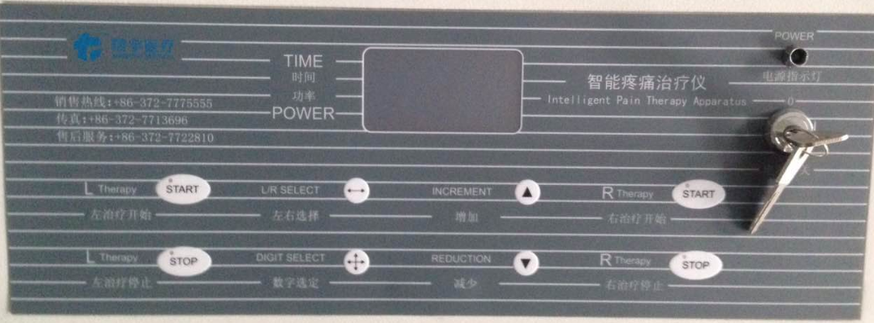

Technological Parameters
- Working temperature: +10℃～+40℃
- Power supply: AC 220V 50Hz
- Power: 80VA
- 1 channel punctiform output, 1 channel planar output
- Length of punctiform radiator: 160mm±5mm
diameter: 30mm±2mm
- Wavelength of punctiform radiator: 810nm±5%
- Output power of punctiform radiator: 0~500mw
- Dimension of planar radiator: 200mm*160mm*50mm
- Wavelength of planar radiator: 980/810nm±5%
- Treatment time: 0~99min
Operating steps
Error: Reference source not found. Preparation
This apparatus uses three-pin 220V power source (in other words, the power source must have the protection of ground wire).

Error: Reference source not found. Starting the apparatus
Inset the key into the key jack and rotate 90 degrees clockwise until you see the green indicator lamp (POWER) lights up, which implies the power has been connected well. When you have pressed the button of standby, its indicator lamp will light up. In about two seconds, the apparatus will enter standby state where it can start and output. When you press the standby button again, the apparatus will switch into holding state where it cannot output.

Error: Reference source not found. Setting the treatment time
1. Set the treatment time according to different diseases within the range of 1-99 min.
2. Use L/R SELECT key to choose the left road parameters or the right road parameters need to be set. You can adjust them when the figures on screen flash. Having chosen the right or the left road, you can use DIGIT SELECT key to select the treatment time or treatment power need to be set.
3. Having selected the data needed to be adjusted, you can increase the values by INSCREMENT key or decrease it by REDUCTION key, and the value being adjusted will keep decreasing or increasing quickly if you continue pressing the corresponding key.
4. The working time is continuously adjustable within 1~99min and the way of time keeping is countdown. Press the starting key and the device will start working and counting down with 1 minute as time unit. It stops working by itself and sends out a warning sound signal of 8s when the displayed time becomes 00. Press the stop key to stop the warning sound.

Matters Need Attention
Error: Reference source not found. Notice for secure use
1. Remember not to turn off the power source directly but press the STOP key before turning off in case that the radiator be damaged.
2. Never plug in or pull out output probe A after starting; otherwise the radiator may be damaged.
3. Handle the output probe carefully.
4. When you have used the output probe, never put it into the disinfectant but rinse it with the disinfectant to disinfect it.
5. Do not look straightly at the window of output probe in case that eyes injure. You may use the output protective glasses of our company.
6. Keep the device clean and do not let various liquids flow into it to avoid internal short-circuiting.

Error: Reference source not found. How to decide appropriate output radiation dose
1. The radiation dose is decided by two parameters: time and radiation power. In case of intra cavitary irradiation, the irradiation power shall be within 250mw~300mw; since the transmission rate of special light bar is above 80%, the actual output rate is within 200~260mw.
2. In case of contact radiation, you can choose the appropriate power in the same way as mentioned above. It needs non-contact radiation. The probe shall be 1~2cm away from the wound surface and the power can be increased by 50mw-100mw.
3. Choosing time
It needs about 3min for radiation on points of contact. The time for non-contact radiation can be prolonged. If the normal radiation that lasts for 3~5min cannot achieve ideal effects, you can prolong it to 6~10min.

Error: Reference source not found. Course of treatment
There must be an interruption between different output treatment courses to obtain continuous treatment effects. The interruption shall last for 4~5 days. Generally, you take the treatment once every day and 5~10 days is one course. You can prolong the radiation time for chronic diseases.

Error: Reference source not found. Patient reactions
Most patients have no obvious reactions, some feel hot or picotement, all of which are normal biological reactions; few patients have burning sensation, meaning that the treatment dose is excessive and you shall adjust the power until the burning sensation disappears.

Error: Reference source not found. The output acupoint radiation shall follow dialectical acupoint selection in traditional Chinese medicine and select the acupoints according to the channel.

Error: Reference source not found. Prepare the skin before radiation when there is hair. Normally, the patient will not feel scorching hot or stimulus pain.

Error: Reference source not found. The operation shall be based on the patients’ condition and the doctor’s experience.

How to install:
1. Open the package and take out the apparatus to check whether there is surface damage.
2. Fasten the screw that set the hand wheel on probe assembly and support assembly.
3. Set free the hand wheel to let the upright tube of the support go upward (note: remember to set it free slowly so that the support will not rise too quickly and hit anybody).
4. Rotate the components of the support clockwise, and press the support downward until it reaches an appropriate height and then wind and fasten the positioning screw of the hand wheel tightly.
5. Plug the joint of electrical wire into host socket.
6. Connect the power line well with the host.

Package, storage, and transport conditions
Storage in transport
1. Range of environment temperature: －40℃～＋55℃;
2. Range of relative humidity: ≤93%;
3. Range of atmosphere pressure: 500～1060hPa；

Conditions of operation
1. Range of environment temperature: 10℃～40℃;
2. Range of relative humidity: 30%～75%;
3. Range of atmosphere pressure: 700～1060hPa.

Safely use and maintain:
We provide free guarantee for this product in one year and supply maintenance service to the customer whenever he uses this apparatus. We can also provide internal circuit drawing for the customer’s reference.
No special maintenance is needed for this apparatus as long as it is used normally. Please don’t repair it by yourself in case of failure lest danger occurs.
The safety category of this product belongs to type B class Error: Reference source not found.
The revealed power of this product equals to the value displayed by dynamometer and the error to real output power is within ±20%. Calibrate the apparatus once every year when it is used normally and this work must be done by the appointed staff from our company; otherwise, it will be very risky.
When the intelligent pains therapeutic apparatus is used normally, the NOHD is 1994.6mm, so we advise the user to pay attention to the distance when operating and avoid direct shining on the non-affected area or on the eye; otherwise, it will cause irreparable harm to the eye.
Please choose the output protective glasses provided by us. It must be prohibited to use flammable anesthetic or oxidizing gases such as nitrous oxide (N2O) and oxygen. Remember the harm of solvent used for cleaning and disinfecting, flammable solution, and internal gases when they are alight.
TROUBLE SHOOTING
TROUBLE | REASON | METHOD | REMARK
No display after power on | Do not plug well | Check whether it plug well
No display after power on | Fuse breaks | Replace fuse
No output | Do not plug well | Check whether it plug well

Replacing the fuse
Just pull out the insurance seat at the power supply hub and replace the fuse. All treatment apparatus is equipped with spare fuse, of which the usage specifications are as follows:

Product Model | Fuse model | Fuse specifications
XYG-500IIIB | φ5×20 | 3A

